**UI Prototypes – User Stories**

**User Story for Management Page:**

US-3: As a condo manager, I want to navigate to different management sections such as properties and employees so that I can separately manage each aspect of the condo.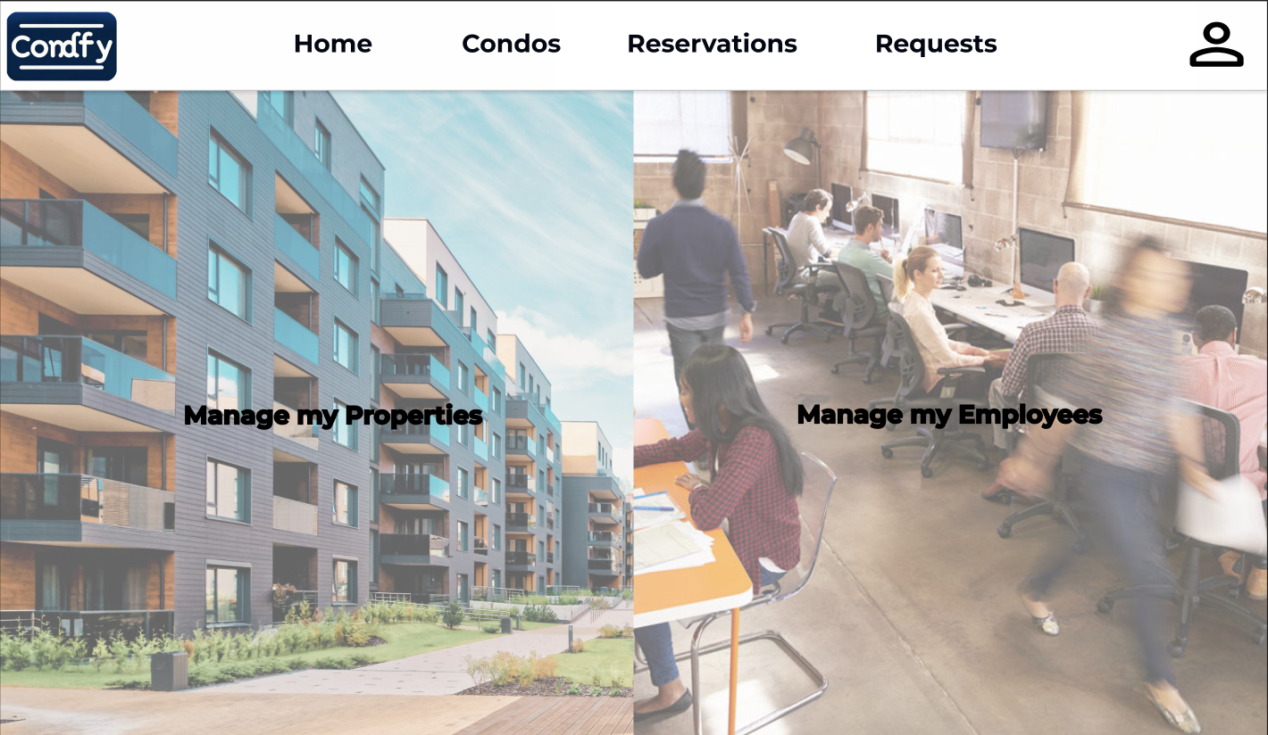

Steps:

1. The condo manager accesses the 'Management Page' after logging in.
2. The manager has the option to select 'Manage my Properties' or 'Manage my Employees', which redirects to the respective management page.

**User Story for Property Dashboard:**

US-4: As a condo manager, I want to view a list of all my properties in one place so that I can easily manage and access specific property details.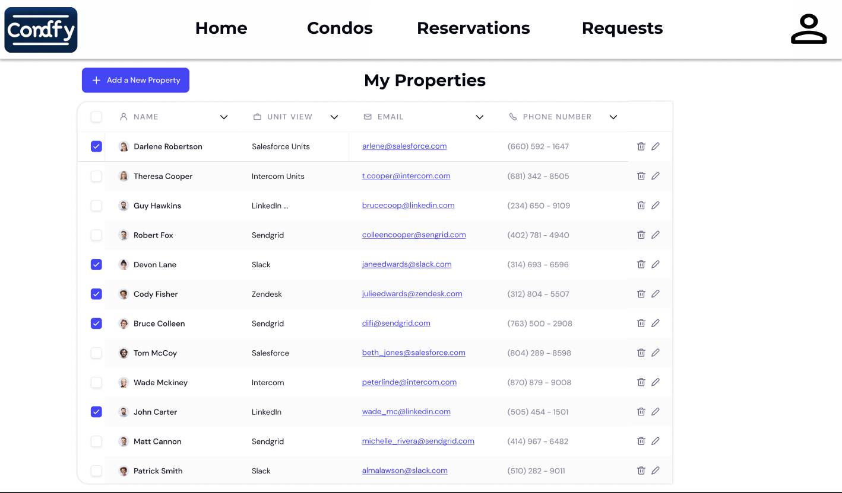

Steps:

1. The condo manager logs in and lands on the 'Property Dashboard'.
2. The dashboard displays a list of properties with details such as property number, address, email, phone number, and action buttons for edit and delete.
3. The manager can sort or search the list for efficient management.

**User Story for Manage My Employees:**

US-5: As a condo manager, I want to manage my employees, view their details, and perform actions like editing and deleting their information.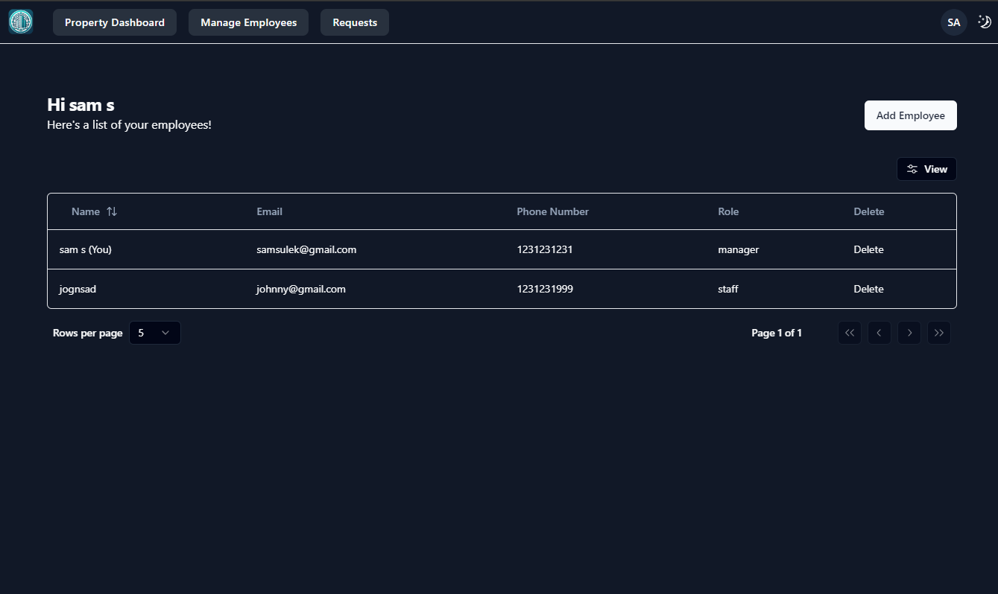

Steps:

1. On the 'Manage my Employees' page, the manager sees a list of employees with details such as staff ID, property they work at, email, and phone number.
2. Action buttons are available for each employee to edit details or remove the employee from the system.

**User Story for Employee Registration:**

US-6: As a condo manager, I want to register new employees to my management system so that they can be assigned tasks and managed within the platform.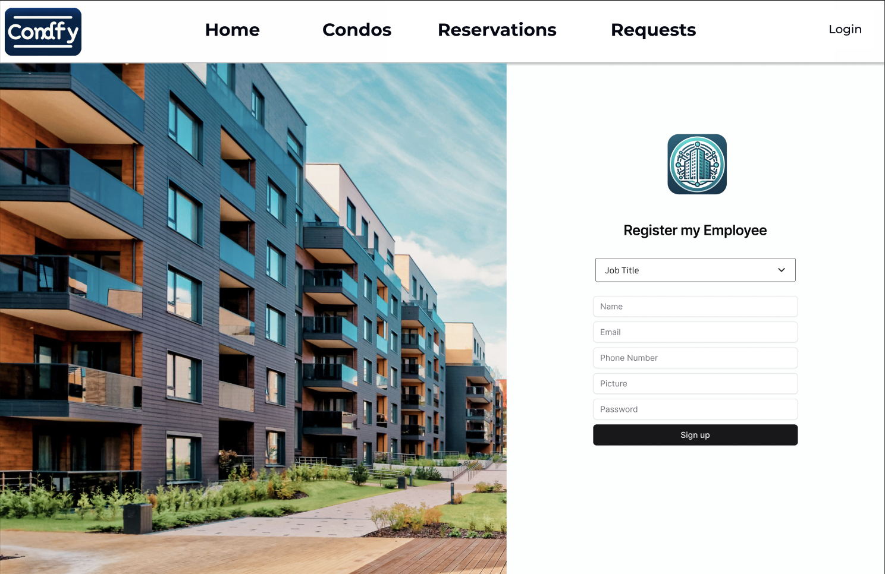

Steps:

1. The condo manager navigates to the 'Employee Registration' page from the management dashboard.
2. The manager fills in the employee's details such as name, email, phone number, and assigns a picture.
3. Upon submitting the form, the employee is registered and added to the 'Manage my Employees' list.

**User Story for Units Dashboard:**

US-7: As a property manager, I want to see a dashboard of all units within a specific property to manage them efficiently.

Steps:

1. The property manager selects a property and is directed to the 'Units Dashboard' for that property.
2. The dashboard displays a list of units with details such as unit number, tenant information, lease dates, and financials.
3. The manager can perform actions like editing unit details, contacting tenants, or updating lease statuses.

**User Story for Create Property Profile:**

US-8: As a property manager, I want to create a new property profile to add to my management portfolio.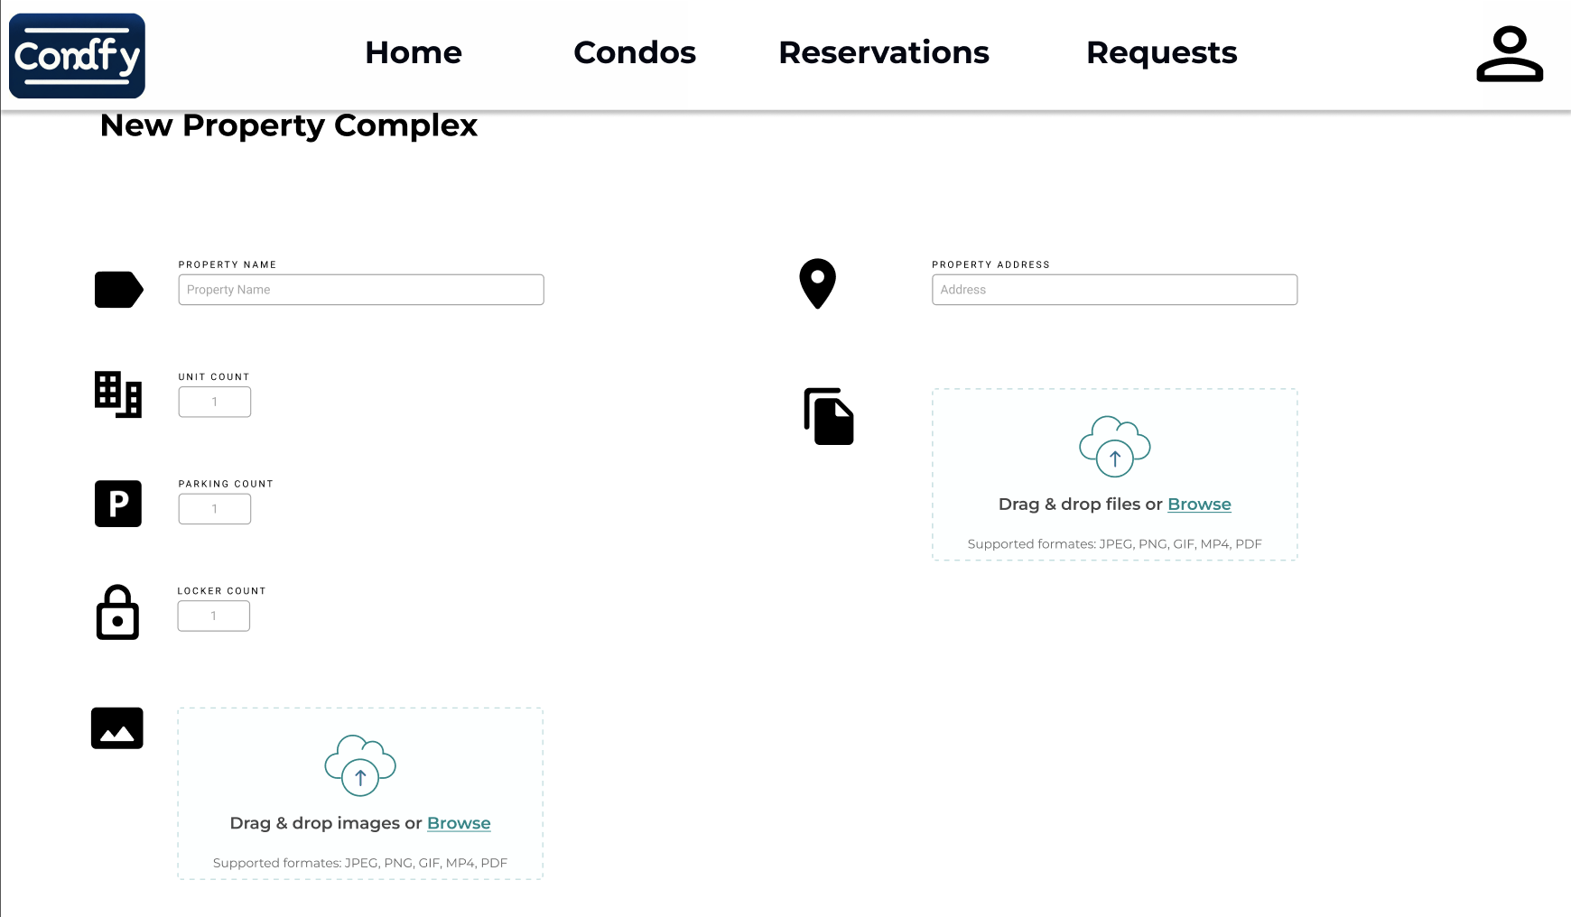

Steps:

1. The property manager navigates to the 'Create Property Profile' page.
2. The manager inputs information such as property name, address, number of units, and uploads images and documents related to the property.
3. Upon submission, the new property is created and added to the manager's portfolio.

**User Story for Create Unit Profile:**

US-9: As a property manager, I want to add individual unit profiles within a property to detail their specific information.

Steps:

1. From within a property's profile, the manager clicks 'Add Unit' to create a new unit profile.
2. The manager enters details like unit number, size, rent amount, and attaches relevant images or documents.
3. After saving, the new unit profile is listed within the property's overall unit list.

**User Story for User Profile Page:**

US-10: As a condo resident or owner, I want to view and edit my personal profile information within the application to keep my contact details up to date.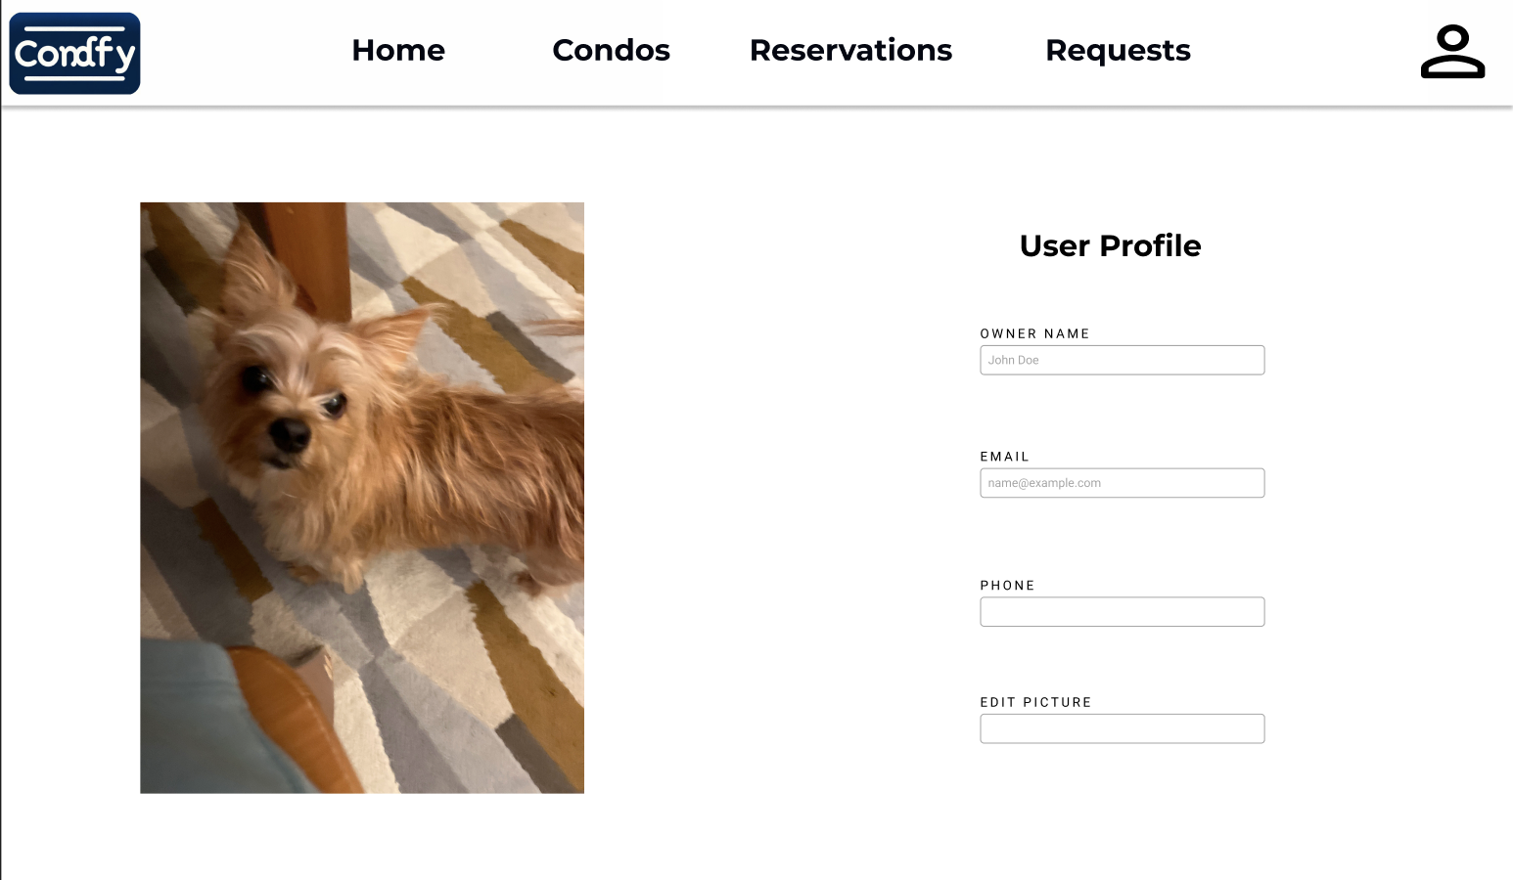

Steps:

1. After logging in, the user navigates to the 'User Profile' page, where their current information is displayed.
2. The user can view their name, email, and phone number as saved in the application.
3. The user has the option to edit any of their personal information, including the ability to change their profile picture.
4. After making the desired changes, the user can save the updates, which are immediately reflected in their profile.